**IST370 Lab 7 (40 points)**

**Theme: Non-Equality Joins & Self Joins**

* Independent Work or
* Teammate's name: ________________

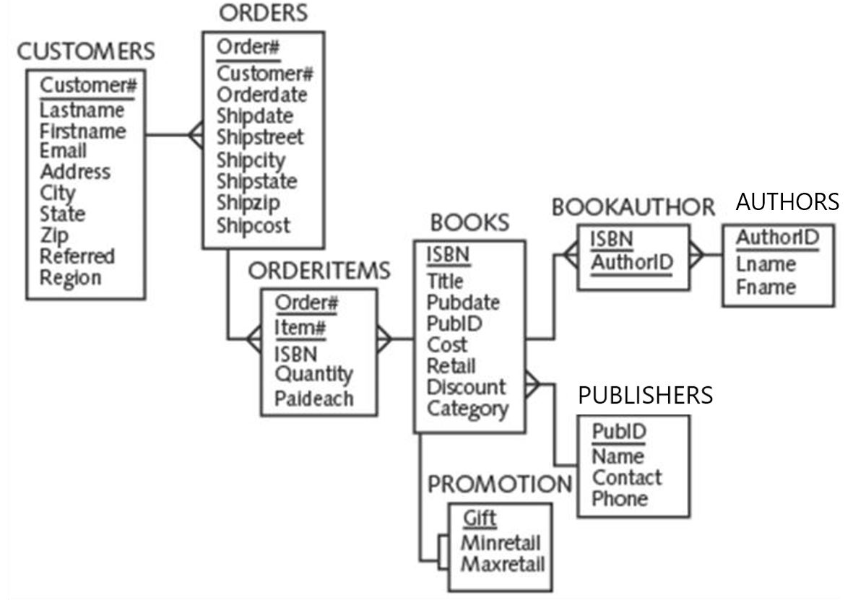

**Instructions: (Not complying with the instructions will lead to a rejection of your submission.)**

1. **Make sure that you crop a screenshot that includes your SQL CODE and the query output under each problem statement.**
2. **The content in each screenshot should be clear enough for legibility.**

Run the following formatting code at the SQL> prompt before your query in order to make the output appear in a desired format.

SET LINESIZE 200

SET PAGESIZE 100

**NON-EQULAITY JOINS**

1. Determine what gift a customer will receive with an order of the book 'E-BUSINESS THE EASY WAY' or 'BIG BEAR AND LITTLE DOVE'. List the customer information. Sort the results in ascending order of order#.

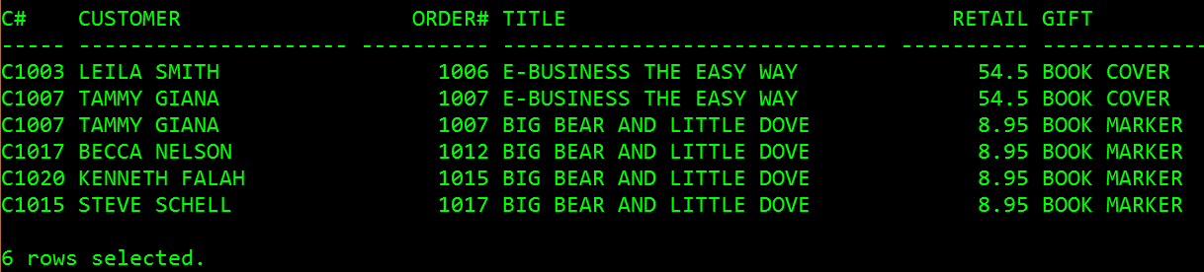

SELECT c.customer# C#, firstname || ‘ ‘ || lastname Customer, c.order#, title, retail, gift

FROM customers c, orders o, orderitems oi, books b, promotion p

WHERE c.customer#= o.customer#

AND o.order#= oi.order#

AND oi.ISBN = b.ISBN

WHERE title IN ('E-BUSINESS THE EASY WAY', 'BIG BEAR AND LITTLE DOVE')

ORDER BY order#;

2. Determine what gift a customer who orders the computer books will receive. Include the book title, retail price, gift, and the publisher contact.

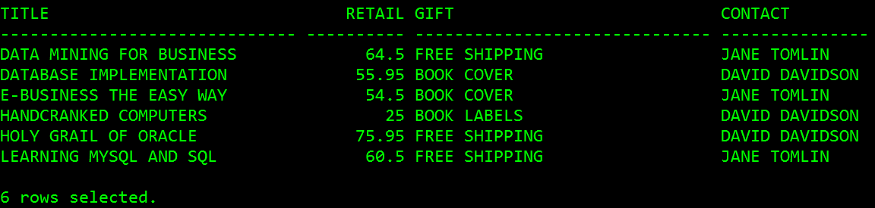

**SELF JOINS**

3. List only those customers who were referred and have made at least one order in the past.

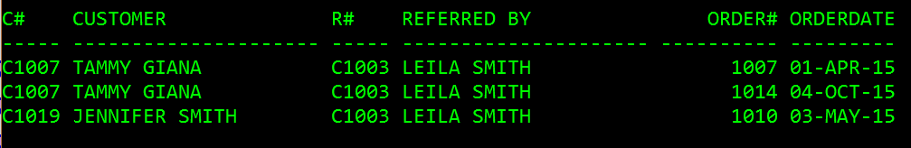

**SELF JOINS & NON-EQUALITY JOINS**

1. (Refer to the following ERD) Display a list of each employee‘s name, monthly salary, pay grade and job title, along with information on his/her manager (i.e., manager‘s name and job title). Use column aliases to clearly identify employee and manager name values. Sort the records by the employee’s job title.

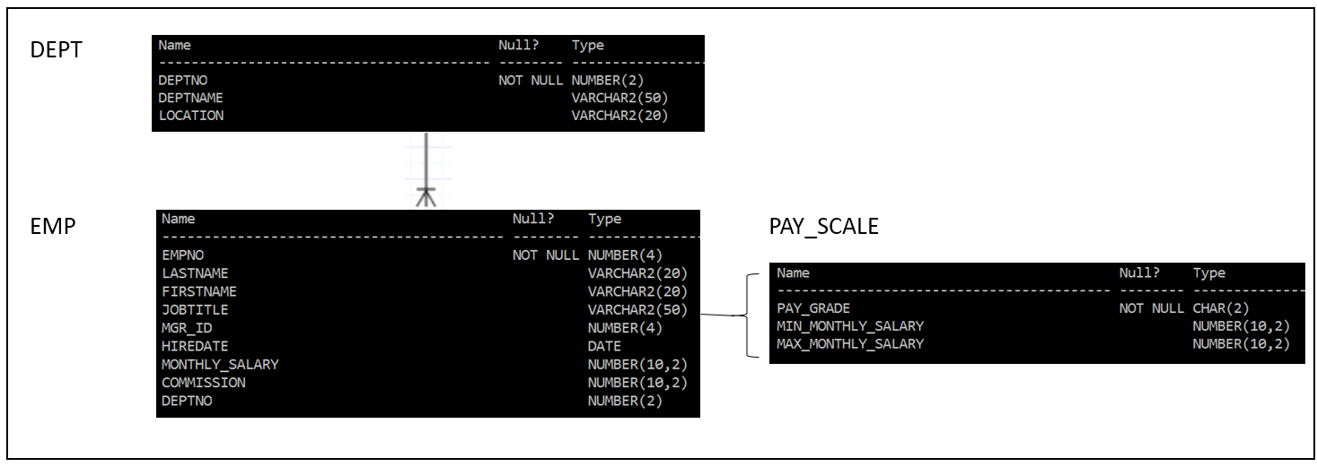

Run the following formatting code at the SQL> prompt before your query in order to produce the output shown as below.

COLUMN "EMPLOYEE" FORMAT A15

COLUMN "MANAGER" FORMAT A15

COLUMN JOBTITLE FORMAT A25

COLUMN PAY_GRADE FORMAT A10

